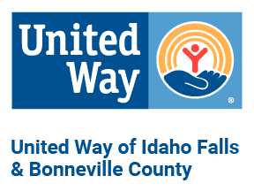
2023-24 United Way Letter of Intent

Organization:
Physical Address:

Mailing Address (if different):

Phone Number:

Grant Contact:

Grant Contact Email:

Total Organization Budget:

Does your organization conduct an independent annual audit or independent financial review (please refer to Community Investment Guidelines)?

Does your organization have a reserve account,(3-6 months operational expenses), if so how much?

Mission Statement:
Program Name:

Program Budget:

Requested Grant Funding Amount:

This proposal best matches United Way of Idaho Falls & Bonneville County goals in the area of (Select one: Education, Health or Financial Stability)

Please describe the program (150 words max.)

How does the program help to achieve United Way’s goals? (150 words max.)

How will the United Way funds be used? (150 words max.)

Please describe why you selected the above program and how it will benefit low-income individuals/families ALICE – Asset Limited, Income Constrained, Employed. (150 words max.)

Email completed LOI with required attachments to cwiersema@unitedwayif.org

