2021 Community Solutions Panel Volunteer Overview

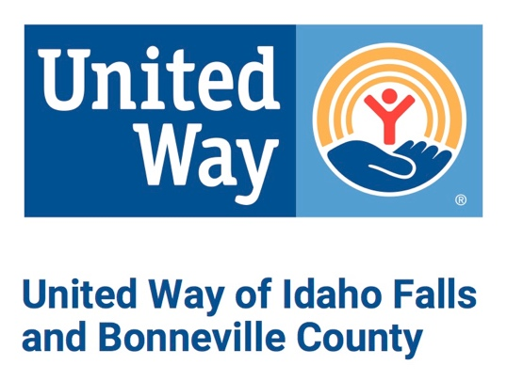

Job Descriptions

Community Solutions Panel Member
Approximate time commitment–20 hours from April through May

As a community solutions volunteer you will carry out UWIFBC’s stewardship role on behalf of our contributors. Your responsibility is to objectively and fairly review the funding requests of local nonprofit organizations and recommend how UWIFBC should invest campaign funds in our communities. You and your fellow volunteers will maintain confidentiality and make every attempt to report and avoid conflicts of interest. Your duties include:

- Read and review all materials provided to you prior to activities. Grant materials will be provided via a web portal for review and scoring.
- Understand and be familiar with UWIFBC’s mission and goals.
- Participate and contribute to your panel.
- Participate in at least one agency visit.
- Participate in agency interviews.

UWIFBC Grant Funding Process Description & Timeline Training

Panel members will be divided into a minimum of five panels. Agency applications will be assigned to panels by the Oversight Committee. Each panel will have approximately 5 applications to review and score.

- Training
- Training for panel members will be held on Tuesday, April 13th. Trainings will be held via ZOOM at 6:30 pm. Panel volunteers are required to attend training session. If the proposed times are in conflict with other events, please contact Karen Tappe (ktappe@unitedwayif.org) to arrange training at another time.

Please contact Chris Wiersema if you have any questions at cwiersema@unitedwayif.org or
208-522-2674.

